# Creating a Custom Activity

## Writing the Custom Activity Code

1. Launch Microsoft Visual Studio.
2. Click **File > New >Project**… (shortcut: Ctrl + Shift + N). The **New Project** window is displayed.
3. Click **Visual C#.** The list of all dependencies using C# is displayed.
4. Optionally, fill in the Name field with a preferred name for your custom activity. In our case, we can use “MathSum”
5. Select **.Net Framework 4.6.1**
6. Select **Class Library (.NET Framework)** and click OK. This helps us export the custom activity as a .dll file.
7. Import the dll ‘**RPA.Genie.Activities.dll**’ to the project.
8. Write the code for your custom activity. In our case, it needs to look something like this’:

|  |
| --- |
| using RPA.Genie.Activities;  using System;  using System.Collections.Generic;  using System.Linq;  using System.Text;  using System.Threading.Tasks;  namespace MathSum  {  public class GetSum : Activity  {  public InProperty<int> FirstValue { get; set; }  public InProperty<int> SecondValue { get; set; }  public OutProperty<int> ResultSum { get; set; }  public override ExecutionResult Execute(IActivityContext activityContext)  {  int firstValue = FirstValue.GetValue(activityContext);  int secoundValue = SecondValue.GetValue(activityContext);  int result = firstValue + secoundValue;  ResultSum.SetValue(activityContext, result);  return ExecutionResult.Empty;  }  }  } |

1. Build project.

## Create NuGet Package

1. Add ‘**Package.json**’ file in your project. Here we specify the activity details

|  |
| --- |
| {  "activities": [  {  "Name": "GetSum",  "Title": "Find sum",  "ActivityId": "07412a30-2b73-4fd1-bfe1-5d524a8a4566",  "Description": "Find sum of 2 values",  "Groups": [  "Calculation",  "Sum"  ],  "Type": "MathSum.GetSum, MathSum",  "Icon": "",  "Properties": [  {  "Name": "FirstValue",  "Group": "Input",  "ValueTypes": [],  "EditorId": "ce349dbb-a586-400b-b661-e5c80d5aa663",  "Required": true  },  {  "Name": "SecondValue",  "Group": "Input",  "ValueTypes": [],  "EditorId": "ce349dbb-a586-400b-b661-e5c80d5aa663",  "Required": true  },  {  "Name": "ResultSum",  "Group": "Output",  "ValueTypes": [],  "EditorId": "ce349dbb-a586-400b-b661-e5c80d5aa663",  "Required": true  }  ]  }  ]  } |

|  |  |
| --- | --- |
| **Field** | **Description** |
| Name | Name of activity |
| Title | Title of activity. This value is shown in activities |
| ActivityId | A unique GUID for activity |
| Description | Activity description |
| Groups | Grouping the activity in Activities panel |
| Type | Fully qualified name of the Activity Class |
| Icon | Icon for activity. No need to specify |
| Properties | List out all input and output properties |

|  |  |
| --- | --- |
| **Field** | **Description** |
| Name | Name of property |
| Group | Property group |
| ValueTypes | Type of values accept. Not required it. |
| EditorId | Type of property input field  **TextBox**: ce349dbb-a586-400b-b661-e5c80d5aa663  **CheckBox**: bb49dbd2-dc73-46de-8753-020379facdc3  **ComboBox**: 1b1219ff-5f51-45d0-b2ae-10ab2acb62d8 |
| Required | Input value is required or not |
| Items | If input type is combox, specify the values. Eg:  "Items": {  "Value0": 0,  "Value1": 1,  "Value3": 2,  "Value4": 3,  "Value5": 4  } |
| DefaultValue | Default value in the input box |

1. Open your project location and paste ‘**nuget.exe**’ here.
2. Open Windows PowerShell window from project path and execute the command ‘**nuget spec**’. Then create new file ‘**MathSum.nuspec**’ in the location. Add this file to project.
3. Open the file ‘**MathSum.nuspec**’

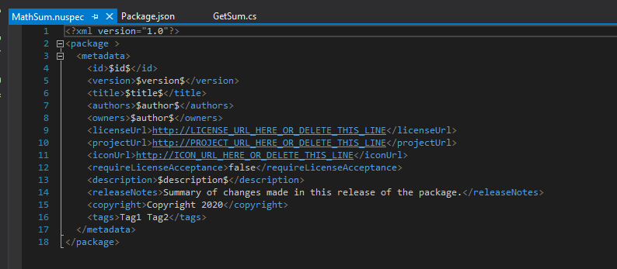

1. Edit details in file ‘**MathSum.nuspec**’. Save and build the project.

|  |
| --- |
| <?xml version="1.0"?>  <package >  <metadata>  <id>Calculation.Plugin</id>  <version>1.0.0</version>  <title>Calculation Plugin</title>  <authors>RPAGenie</authors>  <owners>RPAGenie</owners>  <licenseUrl>http://claysys.com/</licenseUrl>  <projectUrl>http://claysys.com/</projectUrl>  <iconUrl>http://claysys.com/</iconUrl>  <requireLicenseAcceptance>false</requireLicenseAcceptance>  <description>Claculation activities</description>  <releaseNotes>Summary of changes made in this release of the package.</releaseNotes>  <copyright>Copyright 2020</copyright>  <tags>RPAGenie</tags>  </metadata>  </package> |

1. Edit the project file in visual studio(*.csproj), add a new ItemGroup with the bellow code.

|  |
| --- |
| <ItemGroup>  <Content Include="Package.json">  <Pack>true</Pack>  <CopyToOutputDirectory>Always</CopyToOutputDirectory>  </Content>  </ItemGroup> |

1. Open project folder again. Open Windows PowerShell window from path and execute the command ‘**nuget pack**’. Then in folder a file ‘**Calculation.Plugin.1.0.0.nupkg**’ will be create.

Note: Change version number in .nuspec file for nuget package by version number.

1. Move file **‘Calculation.Plugin.1.0.0.nupkg’ to RPAGenie NugetPackages folder.**

Eg: ‘C:\Program Files (x86)\RPA.Genie\NugetPackages’

## Import Nuget Package in RPAGenie Studio

1. Open a project in **RPAGenie studio**
2. In **Project Explorer** right click on **NugetPackages** and click ‘**Manage Package**’.
3. Select package, choose version and click install [If already installed click ‘Upadate’].

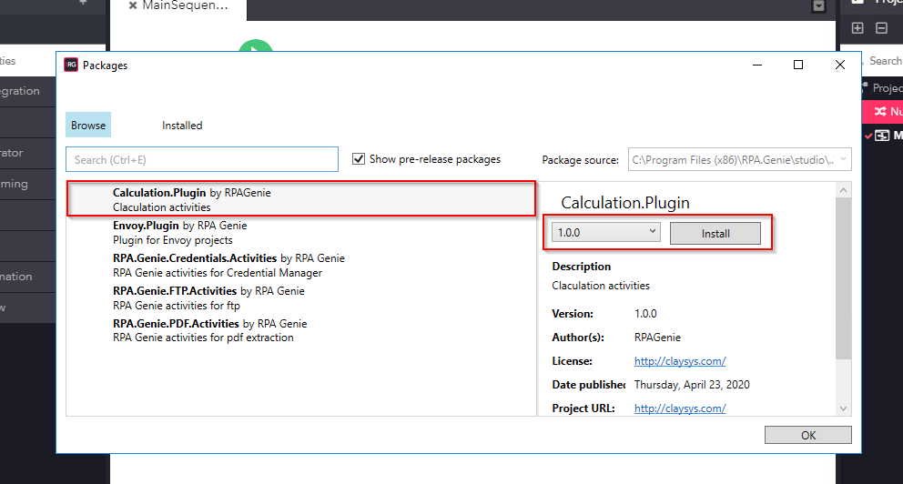

1. Then new activities available in Activity panel.

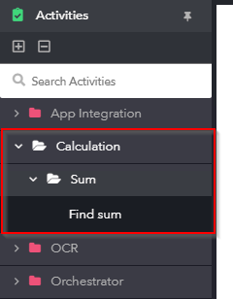

1. Drop and drop the activity

